**STOCK PRICE PREDICTION USING LSTM**

**Dataset Link**: <https://www.kaggle.com/datasets/prasoonkottarathil/microsoft-lifetime-stocks-dataset>

**DATA PREPROCESSING**

**CODE:**

import numpy as np

import pandas as pd

df = pd.read_csv('MSFT.csv')

print(df.head())

df['Date'] = pd.to_datetime(df['Date'])

df = df.sort_values('Date')

from sklearn.preprocessing import MinMaxScaler

scaler = MinMaxScaler()

df['Close'] = scaler.fit_transform(df['Close'].values.reshape(-1, 1))

def create_sequences(data, sequence_length):

sequences = []

for i in range(len(data) - sequence_length):

sequences.append(data[i:i+sequence_length])

return np.array(sequences)

sequence_length = 10 # Choose an appropriate value

X = create_sequences(df['Close'], sequence_length)

train_size = int(0.7 * len(X))

valid_size = int(0.2 * len(X))

X_train = X[:train_size]

X_valid = X[train_size:train_size+valid_size]

X_test = X[train_size+valid_size:]

y_train = df['Close'].iloc[sequence_length:train_size + sequence_length].values

y_valid = df['Close'].iloc[train_size + sequence_length:train_size + valid_size + sequence_length].values

y_test = df['Close'].iloc[train_size + valid_size + sequence_length:].values

X_train = X_train.reshape(-1, sequence_length, 1)

X_valid = X_valid.reshape(-1, sequence_length, 1)

X_test = X_test.reshape(-1, sequence_length, 1)

**OUTPUT**:

Date Open High Low Close Adj Close Volume

0 1986-03-13 0.088542 0.101563 0.088542 0.097222 0.062549 1031788800

1 1986-03-14 0.097222 0.102431 0.097222 0.100694 0.064783 308160000

2 1986-03-17 0.100694 0.103299 0.100694 0.102431 0.065899 133171200

3 1986-03-18 0.102431 0.103299 0.098958 0.099826 0.064224 67766400

4 1986-03-19 0.099826 0.100694 0.097222 0.098090 0.063107 47894400

**FEATURE ENGINEERING:**

**CODE:**

import pandas as pd

data = pd.read_csv('MSFT.csv')

print(data.head())

data['Date'] = pd.to_datetime(data['Date'])

data['Day'] = data['Date'].dt.day

data['Month'] = data['Date'].dt.month

data['Year'] = data['Date'].dt.year

data['Daily_Return'] = data['Adj Close'].pct_change()

data['Lagged_Return_1'] = data['Daily_Return'].shift(1)

data['Lagged_Return_7'] = data['Daily_Return'].shift(7)

data['SMA_5'] = data['Adj Close'].rolling(window=5).mean()

data['SMA_30'] = data['Adj Close'].rolling(window=30).mean()

data['EMA_12'] = data['Adj Close'].ewm(span=12, adjust=False).mean()

data['Avg_Volume_5'] = data['Volume'].rolling(window=5).mean()

data['Volume_Change'] = data['Volume'].pct_change()

def calculate_rsi(data, window=14):

delta = data['Adj Close'].diff(1)

gain = delta.where(delta > 0, 0)

loss = -delta.where(delta < 0, 0)

avg_gain = gain.rolling(window=window).mean()

avg_loss = loss.rolling(window=window).mean()

rs = avg_gain / avg_loss

rsi = 100 - (100 / (1 + rs))

return rsi

data['RSI_14'] = calculate_rsi(data)

print(data.head(100))

**OUTPUT:**

Date Open High Low Close Adj Close Volume \

0 1986-03-13 0.088542 0.101563 0.088542 0.097222 0.062549 1031788800

1 1986-03-14 0.097222 0.102431 0.097222 0.100694 0.064783 308160000

2 1986-03-17 0.100694 0.103299 0.100694 0.102431 0.065899 133171200

3 1986-03-18 0.102431 0.103299 0.098958 0.099826 0.064224 67766400

4 1986-03-19 0.099826 0.100694 0.097222 0.098090 0.063107 47894400

5 1986-03-20 0.098090 0.098090 0.094618 0.095486 0.061432 58435200

6 1986-03-21 0.095486 0.097222 0.091146 0.092882 0.059756 59990400

7 1986-03-24 0.092882 0.092882 0.089410 0.090278 0.058081 65289600

8 1986-03-25 0.090278 0.092014 0.089410 0.092014 0.059198 32083200

9 1986-03-26 0.092014 0.095486 0.091146 0.094618 0.060873 22752000

10 1986-03-27 0.094618 0.096354 0.094618 0.096354 0.061990 16848000

11 1986-03-31 0.096354 0.096354 0.093750 0.095486 0.061432 12873600

12 1986-04-01 0.095486 0.095486 0.094618 0.094618 0.060873 11088000

13 1986-04-02 0.094618 0.097222 0.094618 0.095486 0.061432 27014400

14 1986-04-03 0.096354 0.098958 0.096354 0.096354 0.061990 23040000

15 1986-04-04 0.096354 0.097222 0.096354 0.096354 0.061990 26582400

16 1986-04-07 0.096354 0.097222 0.092882 0.094618 0.060873 16560000

17 1986-04-08 0.094618 0.097222 0.094618 0.095486 0.061432 10252800

18 1986-04-09 0.095486 0.098090 0.095486 0.097222 0.062549 12153600

19 1986-04-10 0.097222 0.098958 0.095486 0.098090 0.063107 13881600

20 1986-04-11 0.098958 0.101563 0.098958 0.099826 0.064224 17222400

21 1986-04-14 0.099826 0.101563 0.099826 0.100694 0.064783 12153600

22 1986-04-15 0.100694 0.100694 0.097222 0.100694 0.064783 9302400

23 1986-04-16 0.100694 0.105035 0.099826 0.104167 0.067016 31910400

24 1986-04-17 0.104167 0.105035 0.104167 0.105035 0.067575 22003200

25 1986-04-18 0.105035 0.105035 0.100694 0.101563 0.065341 21628800

26 1986-04-21 0.101563 0.102431 0.098958 0.101563 0.065341 22924800

27 1986-04-22 0.101563 0.101563 0.099826 0.099826 0.064224 15552000

28 1986-04-23 0.099826 0.100694 0.098958 0.100260 0.064503 15609600

29 1986-04-24 0.100260 0.111979 0.099826 0.110243 0.070926 62352000

30 1986-04-25 0.111111 0.121962 0.111111 0.117188 0.075393 85795200

31 1986-04-28 0.117188 0.118924 0.116319 0.118056 0.075952 28886400

32 1986-04-29 0.118056 0.118056 0.113715 0.114583 0.073718 30326400

33 1986-04-30 0.114583 0.115451 0.109375 0.111979 0.072043 30902400

34 1986-05-01 0.111979 0.111979 0.108507 0.110243 0.070926 54345600

35 1986-05-02 0.110243 0.111979 0.109375 0.110243 0.070926 20246400

36 1986-05-05 0.110243 0.110243 0.109375 0.109375 0.070367 3254400

37 1986-05-06 0.110243 0.111979 0.110243 0.110243 0.070926 9734400

38 1986-05-07 0.110243 0.111111 0.108507 0.110243 0.070926 5155200

39 1986-05-08 0.110243 0.111111 0.109375 0.111111 0.071484 3542400

40 1986-05-09 0.111111 0.111111 0.110243 0.110243 0.070926 6076800

41 1986-05-12 0.110243 0.113715 0.110243 0.111111 0.071484 10483200

42 1986-05-13 0.111111 0.112847 0.111111 0.111979 0.072043 3830400

43 1986-05-14 0.111979 0.111979 0.111111 0.111111 0.071484 9302400

44 1986-05-15 0.111111 0.112847 0.111111 0.111111 0.071484 3801600

45 1986-05-16 0.111111 0.114583 0.111111 0.111979 0.072043 11952000

46 1986-05-19 0.111979 0.111979 0.109375 0.110243 0.070926 11001600

47 1986-05-20 0.110243 0.110243 0.108507 0.109375 0.070367 61977600

48 1986-05-21 0.109375 0.110243 0.107639 0.107639 0.069250 8092800

49 1986-05-22 0.107639 0.108507 0.107639 0.107639 0.069250 4406400

50 1986-05-23 0.107639 0.109375 0.107639 0.107639 0.069250 4089600

51 1986-05-27 0.107639 0.111111 0.107639 0.111111 0.071484 13881600

52 1986-05-28 0.111111 0.114583 0.111111 0.114583 0.073718 15523200

53 1986-05-29 0.114583 0.118924 0.113715 0.117188 0.075393 45676800

54 1986-05-30 0.118056 0.123264 0.118056 0.121528 0.078186 27072000

55 1986-06-02 0.121528 0.121528 0.118056 0.118056 0.075952 19728000

56 1986-06-03 0.118056 0.118056 0.116319 0.118056 0.075952 5011200

57 1986-06-04 0.118056 0.118924 0.116319 0.117188 0.075393 4723200

58 1986-06-05 0.117188 0.118924 0.116319 0.118924 0.076510 13708800

59 1986-06-06 0.118924 0.118924 0.117188 0.118924 0.076510 3427200

RSI_14 Day Month Year Daily_Return Lagged_Return_1 \

0 NaN 13 3 1986 NaN NaN

1 NaN 14 3 1986 0.035716 NaN

2 NaN 17 3 1986 0.017227 0.035716

3 NaN 18 3 1986 -0.025418 0.017227

4 NaN 19 3 1986 -0.017392 -0.025418

5 NaN 20 3 1986 -0.026542 -0.017392

6 NaN 21 3 1986 -0.027282 -0.026542

7 NaN 24 3 1986 -0.028031 -0.027282

8 NaN 25 3 1986 0.019232 -0.028031

9 NaN 26 3 1986 0.028295 0.019232

10 NaN 27 3 1986 0.018350 0.028295

11 NaN 31 3 1986 -0.009001 0.018350

12 NaN 1 4 1986 -0.009099 -0.009001

13 46.666269 2 4 1986 0.009183 -0.009099

14 48.385420 3 4 1986 0.009083 0.009183

15 40.737547 4 4 1986 0.000000 0.009083

16 33.333333 7 4 1986 -0.018019 0.000000

17 40.001432 8 4 1986 0.009183 -0.018019

18 48.001719 9 4 1986 0.018183 0.009183

19 56.520047 10 4 1986 0.008921 0.018183

20 68.183298 11 4 1986 0.017700 0.008921

21 80.000000 14 4 1986 0.008704 0.017700

22 77.777778 15 4 1986 0.000000 0.008704

23 78.946376 16 4 1986 0.034469 0.000000

24 77.777778 17 4 1986 0.008341 0.034469

25 66.663825 18 4 1986 -0.033060 0.008341

26 70.000000 21 4 1986 0.000000 -0.033060

27 61.903138 22 4 1986 -0.017095 0.000000

28 60.974758 23 4 1986 0.004344 -0.017095

29 75.000000 24 4 1986 0.099577 0.004344

30 84.209782 25 4 1986 0.062981 0.099577

31 84.209782 28 4 1986 0.007414 0.062981

32 74.998881 29 4 1986 -0.029413 0.007414

33 69.048431 30 4 1986 -0.022722 -0.029413

34 64.286323 1 5 1986 -0.015505 -0.022722

35 63.414421 2 5 1986 0.000000 -0.015505

36 61.903138 5 5 1986 -0.007881 0.000000

37 58.975301 6 5 1986 0.007944 -0.007881

38 57.894737 7 5 1986 0.000000 0.007944

39 65.713409 8 5 1986 0.007867 0.000000

40 63.889580 9 5 1986 -0.007806 0.007867

41 68.571575 12 5 1986 0.007867 -0.007806

42 69.015434 13 5 1986 0.007820 0.007867

43 51.998281 14 5 1986 -0.007759 0.007820

44 29.415482 15 5 1986 0.000000 -0.007759

45 29.415482 16 5 1986 0.007820 0.000000

46 33.337312 19 5 1986 -0.015505 0.007820

47 38.460479 20 5 1986 -0.007881 -0.015505

48 38.460479 21 5 1986 -0.015874 -0.007881

49 38.460479 22 5 1986 0.000000 -0.015874

50 41.667910 23 5 1986 0.000000 0.000000

51 53.330150 27 5 1986 0.032260 0.000000

52 63.154919 28 5 1986 0.031252 0.032260

53 66.663825 29 5 1986 0.022722 0.031252

54 75.995417 30 5 1986 0.037046 0.022722

55 64.283887 2 6 1986 -0.028573 0.037046

56 62.960016 3 6 1986 0.000000 -0.028573

57 62.960016 4 6 1986 -0.007360 0.000000

58 65.514261 5 6 1986 0.014816 -0.007360

59 64.281604 6 6 1986 0.000000 0.014816

Lagged_Return_7 SMA_5 SMA_30 EMA_12 Avg_Volume_5 Volume_Change

0 NaN NaN NaN 0.062549 NaN NaN

1 NaN NaN NaN 0.062893 NaN -0.701334

2 NaN NaN NaN 0.063355 NaN -0.567850

3 NaN NaN NaN 0.063489 NaN -0.491133

4 NaN 0.064112 NaN 0.063430 317756160.0 -0.293243

5 NaN 0.063889 NaN 0.063123 123085440.0 0.220084

6 NaN 0.062884 NaN 0.062605 73451520.0 0.026614

7 NaN 0.061320 NaN 0.061909 59875200.0 0.088334

8 0.035716 0.060315 NaN 0.061492 52738560.0 -0.508602

9 0.017227 0.059868 NaN 0.061397 47710080.0 -0.290844

10 -0.025418 0.059980 NaN 0.061488 39392640.0 -0.259494

11 -0.017392 0.060315 NaN 0.061479 29969280.0 -0.235897

12 -0.026542 0.060873 NaN 0.061386 19128960.0 -0.138702

13 -0.027282 0.061320 NaN 0.061393 18115200.0 1.436364

14 -0.028031 0.061543 NaN 0.061485 18172800.0 -0.147122

15 0.019232 0.061543 NaN 0.061563 20119680.0 0.153750

16 0.028295 0.061432 NaN 0.061457 20856960.0 -0.377031

17 0.018350 0.061543 NaN 0.061453 20689920.0 -0.380870

18 -0.009001 0.061767 NaN 0.061621 17717760.0 0.185393

19 -0.009099 0.061990 NaN 0.061850 15886080.0 0.142180

20 0.009183 0.062437 NaN 0.062215 14014080.0 0.240664

21 0.009083 0.063219 NaN 0.062610 13132800.0 -0.294314

22 0.000000 0.063889 NaN 0.062945 12942720.0 -0.234597

23 -0.018019 0.064783 NaN 0.063571 16894080.0 2.430341

24 0.009183 0.065676 NaN 0.064187 18518400.0 -0.310469

25 0.018183 0.065900 NaN 0.064364 19399680.0 -0.017016

26 0.008921 0.066011 NaN 0.064515 21553920.0 0.059920

27 0.017700 0.065899 NaN 0.064470 22803840.0 -0.321608

28 0.008704 0.065397 NaN 0.064475 19543680.0 0.003704

29 0.000000 0.066067 0.063210 0.065468 27613440.0 2.994465

30 0.034469 0.068077 0.063638 0.066995 40446720.0 0.375982

31 0.008341 0.070200 0.064010 0.068373 41639040.0 -0.663310

32 -0.033060 0.072098 0.064271 0.069195 44593920.0 0.049850

33 0.000000 0.073606 0.064531 0.069633 47652480.0 0.018993

34 -0.017095 0.073606 0.064792 0.069832 46051200.0 0.758621

35 0.004344 0.072713 0.065108 0.070000 32941440.0 -0.627451

36 0.099577 0.071596 0.065462 0.070057 27815040.0 -0.839260

37 0.062981 0.071038 0.065890 0.070190 23696640.0 1.991150

38 0.007414 0.070814 0.066281 0.070304 18547200.0 -0.470414

39 -0.029413 0.070926 0.066635 0.070485 8386560.0 -0.312849

40 -0.022722 0.070926 0.066933 0.070553 5552640.0 0.715447

41 -0.015505 0.071149 0.067268 0.070696 6998400.0 0.725118

42 0.000000 0.071373 0.067640 0.070903 5817600.0 -0.634615

43 -0.007881 0.071484 0.067975 0.070993 6647040.0 1.428571

44 0.007944 0.071484 0.068292 0.071068 6698880.0 -0.591331

45 0.000000 0.071708 0.068627 0.071218 7873920.0 2.143939

46 0.007867 0.071596 0.068962 0.071173 7977600.0 -0.079518

47 -0.007806 0.071261 0.069260 0.071049 19607040.0 4.633508

48 0.007867 0.070814 0.069483 0.070772 19365120.0 -0.869424

49 0.007820 0.070367 0.069688 0.070538 19486080.0 -0.455516

50 -0.007759 0.069809 0.069855 0.070340 17913600.0 -0.071895

51 0.000000 0.069920 0.070079 0.070516 18489600.0 2.394366

52 0.007820 0.070590 0.070377 0.071009 9198720.0 0.118257

53 -0.015505 0.071819 0.070656 0.071683 16715520.0 1.942486

54 -0.007881 0.073606 0.071009 0.072684 21248640.0 -0.407314

55 -0.015874 0.074947 0.071363 0.073186 24376320.0 -0.271277

56 0.000000 0.075840 0.071717 0.073612 22602240.0 -0.745985

57 0.000000 0.076175 0.072089 0.073886 20442240.0 -0.057471

58 0.032260 0.076399 0.072489 0.074290 14048640.0 1.902439

59 0.031252 0.076063 0.072676 0.074631 9319680.0 -0.750000

**MODEL SELECTION**

**CODE FOR LSTM:**

import numpy

as np import pandas as pd

import matplotlib.pyplot as plt

from sklearn.preprocessing import MinMaxScaler

from keras.models import Sequential from keras.layers

import LSTM, Dense, Dropout

# Load historical stock price data (e.g., CSV file with 'Date'

and 'Close' columns) data = pd.read_csv('MSFT.csv')

# Extract the 'Close' prices as the target variable prices

= data*'Close'+.values.reshape(-1, 1)

# Normalize the data using Min-Max scaling scaler

= MinMaxScaler(feature_range=(0, 1)) prices_scaled

= scaler.fit_transform(prices)

# Define a function to create sequences of data for training

the LSTM model def create_sequences(data, seq_length):

X, y = *+, *+ for i in

range(len(data) - seq_length):

X.append(data*i:i+seq_length+)

y.append(data*i+seq_length+)

return np.array(X), np.array(y)

# Set the sequence length and split the data into training and

testing sets sequence_length = 10

X, y = create_sequences(prices_scaled, sequence_length) train_size

= int(len(X) * 0.8)

X_train, X_test = X*:train_size+, X*train_size:+ y_train,

y_test = y*:train_size+, y*train_size:+ # Create an

LSTM model model

= Sequential()

model.add(LSTM(units=50, return_sequences=True,

input_shape=(X_train.shape*1+, 1)))

model.add(LSTM(units=50)) model.add(Dense(1))

# Compile the model model.compile(optimizer='adam',

loss='mean_squared_error')

# Train the model

model.fit(X_train, y_train, epochs=50, batch_size=64)

# Make predictions on the test set predictions

= model.predict(X_test)

# Inverse transform the predictions to get actual price values

predictions_actual = scaler.inverse_transform(predictions)

y_test_actual = scaler.inverse_transform(y_test)

# Plot the actual vs. predicted prices plt.figure(figsize=(12,

6))

plt.plot(predictions_actual, label='Predicted Prices', color='red')

plt.plot(y_test_actual, label='Actual Prices', color='blue')

plt.title('Stock Price Prediction with LSTM')

plt.xlabel('Time')

plt.ylabel('Price')

plt.legend()

plt.show()

**OUTPUT:**

Epoch 1/50 107/107 *==============================+ - 7s 20ms/step - loss: 0.0011 Epoch 2/50 107/107 *==============================+ - 2s 19ms/step - loss: 3.8592e-05 Epoch 3/50 107/107 *==============================+ - 2s 20ms/step - loss: 3.8419e-05 Epoch 4/50 107/107 *==============================+ - 2s 14ms/step - loss: 3.7421e-05 Epoch 5/50 107/107 *==============================+ - 1s 13ms/step - loss: 3.6841e-05 Epoch 6/50 107/107 *==============================+ - 2s 15ms/step - loss: 3.6274e-05 Epoch 7/50 107/107 *==============================+ - - -05 - 2s 2s 22ms/step loss: 3.6100e Epoch 8/50 107/107 *==============================+ - 2s 15ms/step - loss: 3.6038e-05 Epoch 9/50 107/107 *==============================+ - 2s 21ms/step - loss: 3.4980e-05 Epoch 10/50 107/107 *==============================+ - 2s 21ms/step - loss: 3.3884e-05 Epoch 11/50 107/107 *==============================+ - 2s 21ms/step - loss: 3.1855e-05 Epoch 12/50 107/107 *==============================+ - 2s 21ms/step - loss: 3.1442e-05 Epoch 13/50 107/107 *==============================+ - 2s 16ms/step - loss: 3.2507e-05 Epoch 14/50 107/107 *==============================+ - 2s - -05 - 2s 107/107 *==============================+ 18ms/step - loss: 3.1582e-05 Epoch 15/50 14ms/step loss: 2.8938e Epoch 16/50 107/107 *==============================+ - 2s 23ms/step - loss: 2.6421e-05 Epoch 17/50 107/107 *==============================+ - 2s 22ms/step - loss: 2.6747e-05 Epoch 18/50 107/107 *==============================+ - 2s 19ms/step - loss: 2.4096e-05 Epoch 19/50 107/107 *==============================+ - 2s 18ms/step - loss: 2.5314e-05 Epoch 20/50 107/107 *==============================+ - 2s 20ms/step - loss: 2.5337e-05 Epoch 21/50 107/107 *==============================+ - - -05 - 2s 107/107 *==============================+ - 2s 23ms/step - loss: 2.2405e-05 Epoch 22/50 107/107 *==============================+ 22ms/step - loss: 2.4915e-05 Epoch 23/50 1s 14ms/step loss: 2.1624e Epoch 24/50 107/107 *==============================+ - 2s 19ms/step - loss: 2.1545e-05 Epoch 25/50 107/107 *==============================+ - 2s 22ms/step - loss: 2.2694e-05 Epoch 26/50 107/107 *==============================+ - 2s 22ms/step - loss: 2.0566e-05 Epoch 27/50 107/107 *==============================+ - 2s 19ms/step - loss: 2.2009e-05 Epoch 28/50 107/107 *==============================+ - 2s - -05 - 2s 107/107 *==============================+ - 2s 18ms/step - loss: 2.2940e-05 Epoch 29/50 107/107 *==============================+ - 2s 15ms/step - loss: 2.0115e-05 Epoch 30/50 107/107 *==============================+ 22ms/step - loss: 1.8910e-05 Epoch 31/50 23ms/step loss: 2.3294e Epoch 32/50 107/107 *==============================+ - 2s 19ms/step - loss: 1.8463e-05 Epoch 33/50 107/107 *==============================+ - 2s 19ms/step - loss: 2.0214e-05 Epoch 34/50 107/107 *==============================+ - 2s 22ms/step - loss: 1.8284e-05 Epoch 35/50 107/107 *==============================+ - - -05 - 2s 107/107 *==============================+ - 2s 23ms/step - loss: 1.7490e-05 Epoch 36/50 107/107 *==============================+ - 2s 21ms/step - loss: 1.8360e-05 Epoch 37/50 107/107 *==============================+ - 2s 19ms/step - loss: 1.7240e-05 Epoch 38/50 107/107 *==============================+ 21ms/step - loss: 1.6853e-05 Epoch 39/50 3s 24ms/step loss: 1.5736e Epoch 40/50 107/107 *==============================+ - 2s 22ms/step - loss: 1.5684e-05 Epoch 41/50 107/107 *==============================+ - 2s 15ms/step - loss: 1.7331e-05 Epoch 42/50 107/107 *==============================+ - 2s - -05 - 2s 107/107 *==============================+ - 2s 23ms/step - loss: 1.6515e-05 Epoch 43/50 107/107 *==============================+ - 2s 21ms/step - loss: 1.6822e-05 Epoch 44/50 107/107 *==============================+ - 2s 16ms/step - loss: 1.4114e-05 Epoch 45/50 107/107 *==============================+ - 2s 23ms/step - loss: 1.4346e-05 Epoch 46/50 107/107 *==============================+ 21ms/step - loss: 1.5537e-05 Epoch 47/50 2s - -05 19ms/step loss: 1.4485e Epoch 48/50 107/107 *==============================+ - 2s 23ms/step - loss: 1.4945e-05 Epoch 49/50 107/107 *==============================+ - 2s 22ms/step - loss: 1.3325e-05 Epoch 50/50 107/107 *==============================+ - 2s 19ms/step - loss: 1.2995e-05 54/54 *==============================+ - 1s 3ms/step Process finished with exit code 0

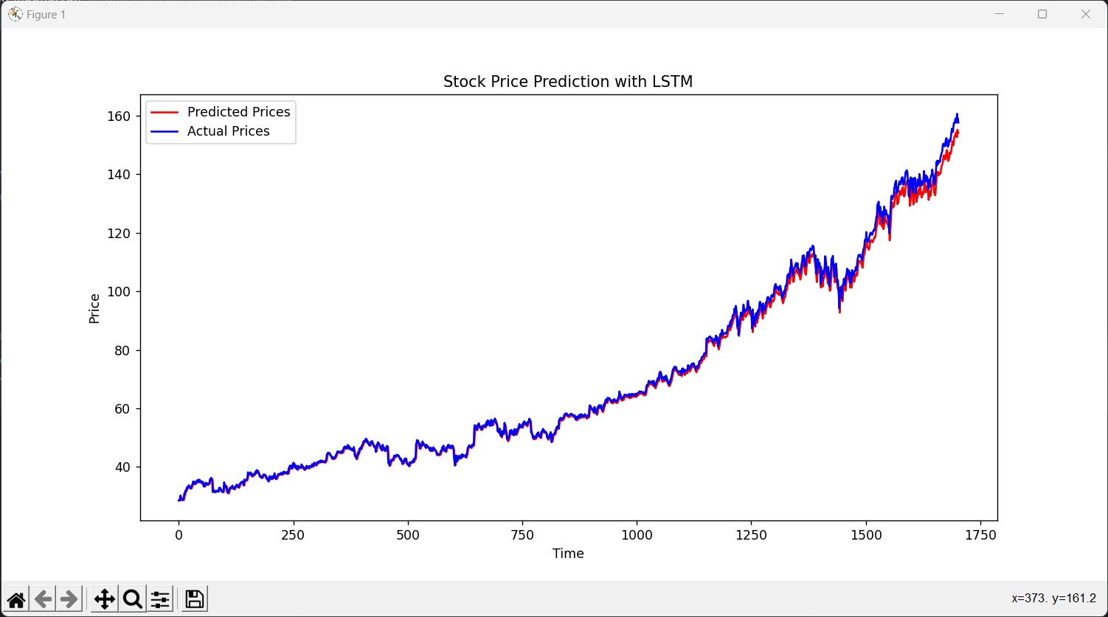

**MODEL TRAINING**

**CODE:**

data['Date'] = pd.to_datetime(data.Date,format='%Y/%m/%d %H:%M:%S')

data.index = data['Date']

plt.figure(figsize=(16,8))

plt.plot(data['Close'], label='Close Price history',color='g')

plt.xlabel('Date',size=20)

plt.ylabel('Stock Price',size=20)

plt.title('Stock Price of Microsoft over the Years',size=25)

def lstm_prediction(df):

shape=df.shape[0]

df_new=df[['Close']]

df_new.head()

dataset = df_new.values

train=df_new[:ceil(shape*0.75)]

valid=df_new[ceil(shape*0.75):]

print('-----------------------------------------------------------------------------')

print('-----------STOCK PRICE PREDICTION BY LONG SHORT TERM MEMORY (LSTM)-----------')

print('-----------------------------------------------------------------------------')

print('Shape of Training Set',train.shape)

print('Shape of Validation Set',valid.shape)

scaler = MinMaxScaler(feature_range=(0, 1))

scaled_data = scaler.fit_transform(dataset)

x_train, y_train = [], []

for i in range(40,len(train)):

x_train.append(scaled_data[i-40:i,0])

y_train.append(scaled_data[i,0])

x_train, y_train = np.array(x_train), np.array(y_train)

x_train = np.reshape(x_train, (x_train.shape[0],x_train.shape[1],1))

model = Sequential()

model.add(LSTM(units=50, return_sequences=True, input_shape=(x_train.shape[1],1)))

model.add(LSTM(units=50))

model.add(Dense(1))

model.compile(loss='mean_squared_error', optimizer='adam')

model.fit(x_train, y_train, epochs=1, batch_size=1, verbose=2)

inputs = df_new[len(df_new) - len(valid) - 40:].values

inputs = inputs.reshape(-1,1)

inputs = scaler.transform(inputs)

X_test = []

for i in range(40,inputs.shape[0]):

X_test.append(inputs[i-40:i,0])

X_test = np.array(X_test)

X_test = np.reshape(X_test, (X_test.shape[0],X_test.shape[1],1))

closing_price = model.predict(X_test)

closing_price = scaler.inverse_transform(closing_price)

rms=np.sqrt(np.mean(np.power((valid-closing_price),2)))

print('RMSE value on validation set:',rms)

print('-----------------------------------------------------------')

print('-----------------------------------------------------------')

valid['Predictions'] = closing_price

plt.plot(train['Close'])

plt.plot(valid[['Close','Predictions']])

plt.xlabel('Date',size=20)

plt.ylabel('Stock Price',size=20)

plt.title('Stock Price Prediction by Long Short Term Memory (LSTM)',size=20)

plt.legend(['Model Training Data','Actual Data','Predicted Data'])

**OUTPUT:**

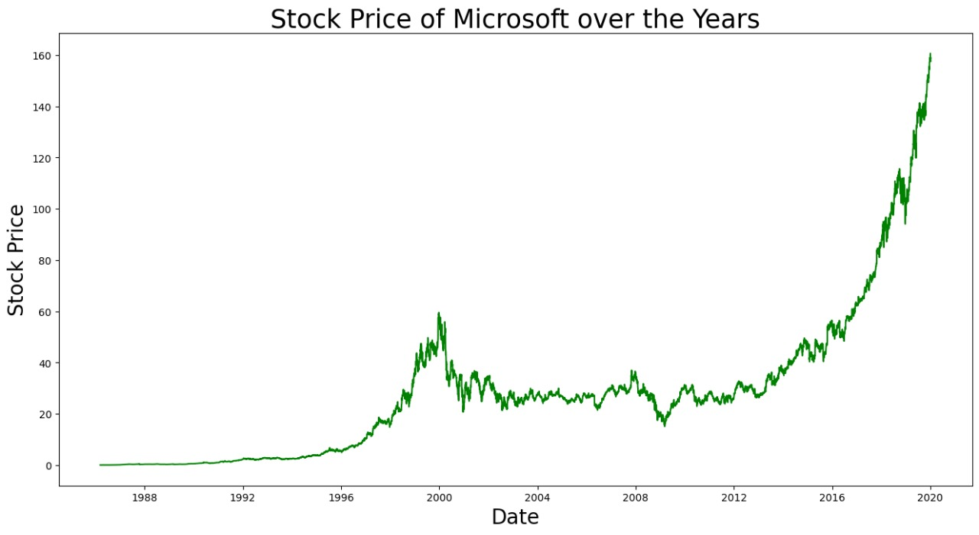

-----------------------------------------------------------------------------

-----------STOCK PRICE PREDICTION BY LONG SHORT TERM MEMORY (LSTM)-----------

-----------------------------------------------------------------------------

Shape of Training Set (1134, 1)

Shape of Validation Set (377, 1)

1094/1094 - 19s - loss: 4.5201e-04

RMSE value on validation set: Close 9.464954

dtype: float64

-----------------------------------------------------------

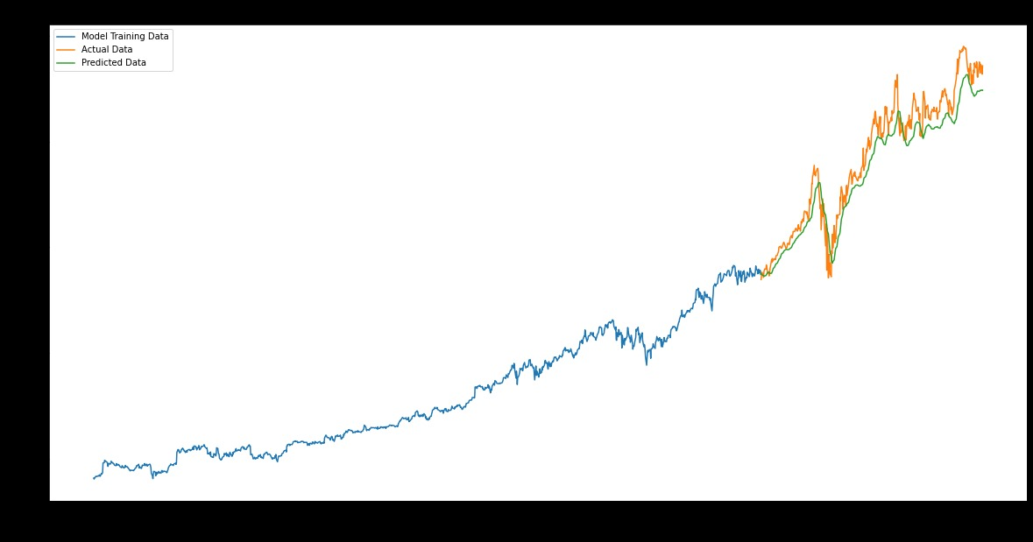

**EVALUATION**

**CODE:**

import numpy as np

import pandas as pd

import matplotlib.pyplot as plt

from sklearn.preprocessing import MinMaxScaler

from tensorflow.keras.models import Sequential

from tensorflow.keras.layers import LSTM, Dense, Dropout

# Load the stock price data

data = pd.read_csv('MSFT.csv') # Replace 'stock_data.csv' with your dataset

# Select the 'Close' prices as the target variable

prices = data['Close'].values.reshape(-1, 1)

# Normalize the data

scaler = MinMaxScaler(feature_range=(0, 1))

prices_scaled = scaler.fit_transform(prices)

# Split the data into training and test sets

train_size = int(len(prices_scaled) * 0.8)

train_data = prices_scaled[:train_size]

test_data = prices_scaled[train_size:]

# Create sequences of data for training

def create_sequences(data, sequence_length):

X, y = [], []

for i in range(len(data) - sequence_length):

X.append(data[i:i+sequence_length])

y.append(data[i+sequence_length])

return np.array(X), np.array(y)

sequence_length = 10 # You can adjust this value

X_train, y_train = create_sequences(train_data, sequence_length)

X_test, y_test = create_sequences(test_data, sequence_length)

# Build the LSTM model

model = Sequential()

model.add(LSTM(units=50, return_sequences=True,

input_shape=(X_train.shape[1], 1)))

model.add(LSTM(units=50))

model.add(Dense(units=1))

model.compile(optimizer='adam', loss='mean_squared_error')

# Train the model

model.fit(X_train, y_train, epochs=10, batch_size=32)

# Evaluate the model

train_loss = model.evaluate(X_train, y_train, verbose=0)

test_loss = model.evaluate(X_test, y_test, verbose=0)

print(f"Train Loss: {train_loss:.4f}, Test Loss: {test_loss:.4f}")

# Make predictions

train_predictions = model.predict(X_train)

test_predictions = model.predict(X_test)

# Inverse transform the predictions to the original scale

train_predictions = scaler.inverse_transform(train_predictions)

test_predictions = scaler.inverse_transform(test_predictions)

# Plot the results

plt.figure(figsize=(12, 6))

plt.plot(prices, label='Actual Prices', color='b')

plt.plot(range(sequence_length, train_size), train_predictions, label='Train

Predictions', color='g')

plt.plot(range(train_size + sequence_length, len(prices)), test_predictions,

label='Test Predictions', color='r')

plt.legend()

plt.show()

**OUTPUT:**

Epoch 1/10 213/213 [==============================] - 8s 14ms/step - loss: 5.6418e-04

Epoch 2/10 213/213 [==============================] - 3s 13ms/step - loss: 4.2065e-05

Epoch 3/10 213/213 [==============================] - 3s 15ms/step - loss: 4.1125e-05

Epoch 4/10 213/213 [==============================] - 6s 27ms/step - loss: 4.0485e-05

Epoch 5/10 213/213 [==============================] - 6s 27ms/step - loss: 4.4396e-05

Epoch 6/10 213/213 [==============================] - 5s 26ms/step - loss: 3.7652e-05

Epoch 7/10 213/213 [==============================] - 3s 14ms/step - loss: 3.3948e-05

Epoch 8/10 213/213 [==============================] - 3s 13ms/step - loss: 3.4644e-05

Epoch 9/10 213/213 [==============================] - 3s 14ms/step - loss: 3.2606e-05

Epoch 10/10 213/213 [==============================] - 4s 18ms/step - loss: 2.8910e-05

Train Loss: 0.0000, Test Loss: 0.0008 213/213 [==============================] - 2s 4ms/step 53/53 [==============================] - 0s 5ms/step

